Bryn Mawr Elementary School

5TH GRADE ACTIVITIES
Week of April 13th-April 17th
SUBJECT | LEARNING ACTIVITIES
READING | Continue reading and researching on Western Expansion  This week you should have:  Your topic chosen and planned how you will organize your report  Chosen 3-6 sub-topics that you will be able to write at least a paragraph about  Have a note taking system that works for you to include notes on big ideas, connections, important people, places, and dates and start looking for impactful quotes and anecdotes to add in your report
WRITING | Start on revising and editing your fiction story using the 5th grade narrative checklist (A copy is included below)  Read once to yourself and then read a second time out loud to a listener or to yourself  Write/type a final copy.
MATH | Work on memorizing your basic multiplication and division facts through 10 x 10  Complete the Triangle Challenge at this website: https://mathforlove.com/2020/03/harmonic-triangle-challenge/  Click on the PDF and print the form, or copy the image into your notebook. Watch the video at the bottom of the page. You will need to pause the video when the speaker tells you and complete work step-by-step.  Choose one fractions practice page below and complete it.
SCIENCE | Watch Magic School Bus Gets Eaten.  Share with your family or write in your spiral the food chain that is described in the video. Explain how the energy is passed along from the producer to the consumer to decomposer.  https://www.schooltube.com/media/Magic+school+bus+gets+eaten/1_gao63d1o  Watch, listen and explore Dry Tortugas National Park. Share with your family or describe in your spiral what you learn about the Dry Tortugas ecosystem.  https://artsandculture.withgoogle.com/en-us/national-parks-service/dry-tortugas
MUSIC | Hello Musical Mustangs!  Let’s go on a m u s i c a l j o u r n e y! You’re going to need a way to listen to music and your parents to help you with this. This week Mr. Deuel and I would like you to explore different styles of music. The goal is to talk about different musical styles, and give at least two reasons why you like a certain style or not. Here’s how you can do this:  - Using music in your house or music you find online, explore the different styles on the image below.  - Using the image below, try to see if the song you listened to is rock, rap, classical, and so on….  - Write down in your journal two reasons why you think it is the style you decided, and two reasons why you like it or do not like it.  - Extra stuff for fun: Film yourself talking about this music and send it to me in Class Dojo OR email it to jdupea@g.rentonschools.us  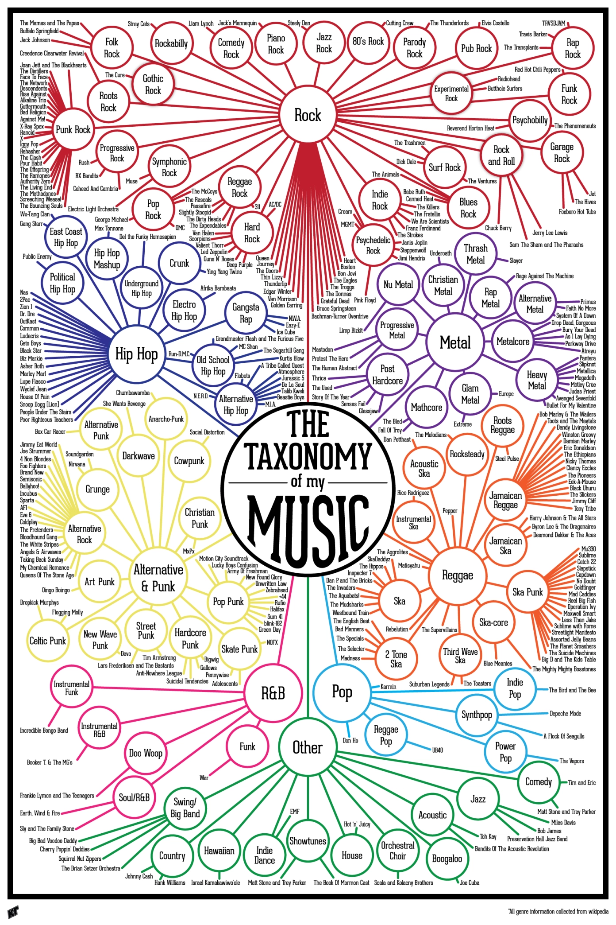  *If you’re interested in more music activities and music videos, email Mr. Dupea at jdupea@g.rentonschools.us to see how to log in to Classdojo.com or Classroom.google.com
PE | 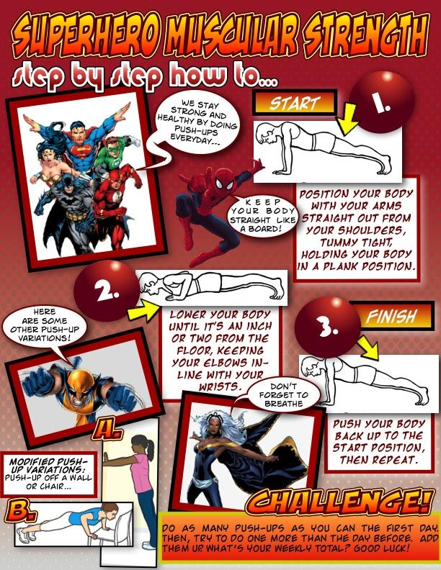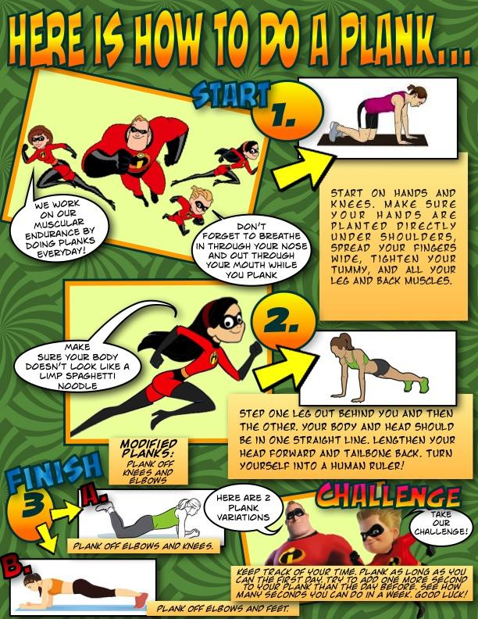  - - - - - - - - - - - - - - - - - - - - - - - - - - - - - - - - - - - - - - - - - - - - - - - - - - - - - - - - - - - - - - - - - - - - - -  Air Bowling: A Stationary Target Activity  A game of practice and fun for K-2nd grade!!  Object of game: Send an object of choice through the air to knock down a variety of targets found from around your home.  Where to play: Outside (or inside *see safety) Learning Target: Throwing at targets to knock them down.  - EQUIPMENT NEEDED:  4-10 empty items: plastic bottles, cans, small cardboard items/boxes of all sizes, (bowling pins if you have them). 1-4 objects for throwing (various sizes, big and small balls): rolled up socks, shoes, bean bag items, big plastic lids, foam noodles, balls.  2. *SAFETY: If inside use soft items (for example socks) to throw and then set your boundary a safe distance from walls with windows or breakables. Be careful!  3. RULES:  -You get 2 throws to try and knock down items (just like in real bowling).  -Take turns with partner😊  -Have fun!  4. PARTNER CHALLENGE OR SELF-CHALLENGE:  Partner Challenge: Trade off setting up and knocking down the targets. One sets up, the other gets two tries to knock the targets down, then trade places.  Self-challenge: How many tries did it take you to knock the target down? Reset and try to beat your score. Partner Challenges: Set a distance and an order for hitting the targets that creates the best challenges.  5. THROWING FORM SUGGESTIONS:  --Step with opposite foot  --Underhand throw = swing arm gently like a bell  --Overhand throw= start with elbow up and out, and hand by ear  6. SCORING: add your points for each throw  STRIKE= ALL items knocked down in one throw! How many times did you get a strike?  SPARE= All items knocked down in 2 tries of throwing. How many items did you knock down in first throw?  FUN THINGS TO THINK ABOUT:  Did you throw overhand or underhand? Which throwing item worked best for you (a big object or a small object to send)? Did you need to get closer to the target or further away? Modify for what works best for you and partner!  - - - - - - - - - - - - - - - - - - - - - - - - - - - - - - - - - - - - - - - - - - - - - - - - - - - - - - - - - - - -- - - - - - - - - - - - - - -  Air Bowling: A Stationary Target Activity  A game of practice and fun for student’s 3rd-5th grade…sending an object of choice through the air to knock down a variety of targets found from around your home… Learning Target: Throwing skills and effort awareness- applying force to send an object at targets to knock them down.  1. You need 4-10 empty items for stacking or self-standing (plastic bottles, cans, small cardboard items/ boxes of all sizes, bowling pins if you have them). 1-4 objects for throwing (various sizes, big and small balls). Optional items for throwing if you do not have a ball: rolled up socks, shoes, bean bag items, big plastic lids, foam noodles.  2. For Safety: Inspect the activity area and make sure it is safe for throwing. Set your boundary a safe distance from walls with windows or breakables. If inside use soft items to throw.  3. This activity can be done as a partner challenge or self-challenge. First have a practice session. You can set up two targets and practice your throws. Partner Challenge: Trade off setting up and knocking down the targets. When ready challenge each other. One sets up, while the other one gets two tries to knock the targets down, then trade places. Self-challenge: How many tries did it take you to knock the target down? Reset and try to beat your score with less tosses. Both Challenges: Come up with a distance and an order for hitting the targets that creates the best challenge and the most fun.  4. Things to think about for throwing: How many items can you knock down in one throw? Did you get a strike (knock all down at once)? How many times did you get a spare (second try got them all down)? Did you throw overhand or underhand? Which throwing item worked best for you (a big object or a small object to send)? Did you need to get closer to the target or further away? Were you able to come up with other items for sending or knocking over the targets that I did not think of? We would love to hear your feedback.  CHALLENGE OPTIONS: Throwing the shoe like a football, plastic lid like a frisbee, foam noodle like a javelin,  bigger items, smaller items (remember no breakables). Make the throwing distance further or shorter. Whatever works best for you and your partner. Using a bat or racquet to strike items towards the target (see items below).  ADAPTIONS: To decrease the challenge, you can decrease the distance, lower the targets, roll a ball on the ground. Use only large targets (e.g., empty jugs, cartons, liter bottles, cereal or cracker boxes). If challenging a younger person let them move closer to the target. To increase the challenge, increase the distance. Use different throws; overhand, underhand, lob. Use a striking implement to send the object towards the target (bat, hockey stick, racquet).  MOVEMENT STRATEGIES: Applying appropriate skills to send an object to improve control and accuracy. Throwing keys to success: Underhand throw-Stand facing your target, swing your throwing arm back with ball in hand, step with opposite foot forward as you throw, release ball between your knee & waist level, following through with hand towards object. Overhand Throw – Stand sideways to your target T-up, bring your throwing arm back (make upper case “L” with throwing arm at shoulder height), step with opposite foot of throwing arm forward (as you throw your elbow leads the throw), rotate your hips and spine as you throw following through with your hand to the target!  ------------------------------------------------------------------------------------------------------------------------------------------
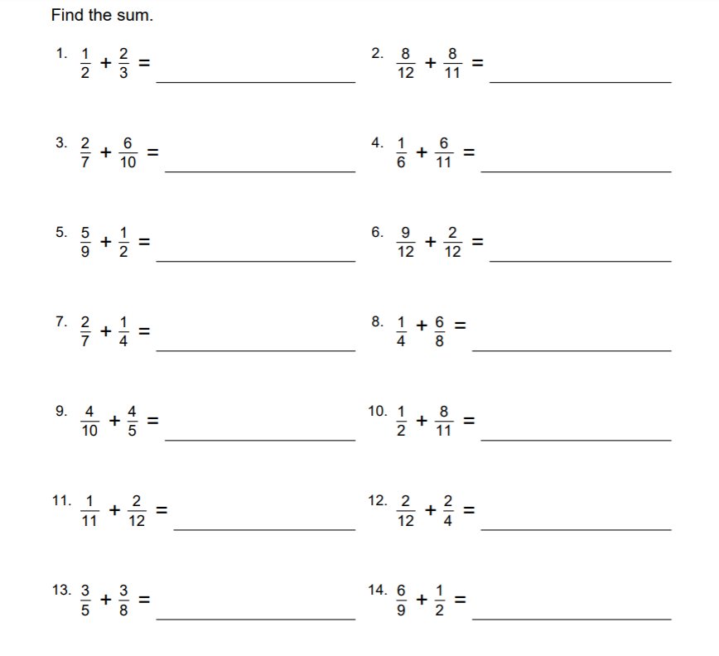

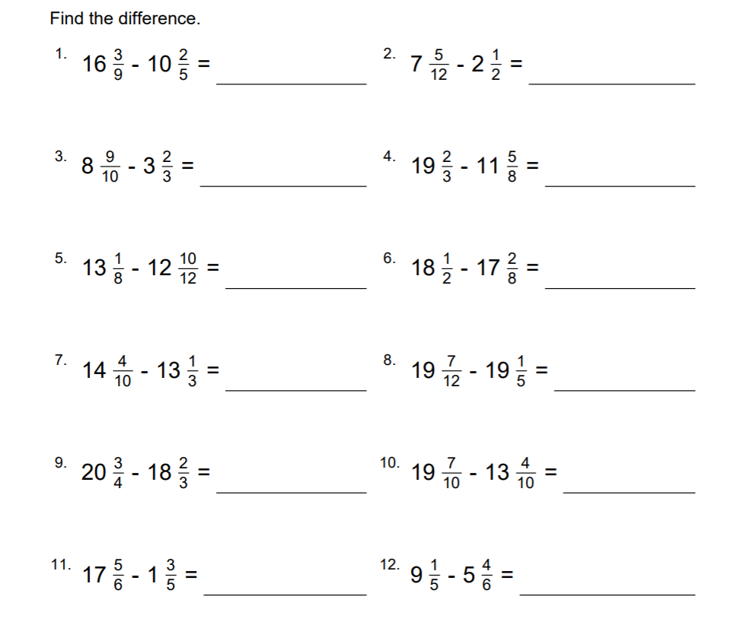

Westward Expansion Research Report: Organization

You have spent the last few weeks introducing yourself to Westward Expansion, and getting an overview of what it is. Now it’s time to start narrowing your research and organizing your notes. This week, you will choose a big idea for your research. Then you will think through at least 3 subtopics that connect to your main idea. The checklist your teacher provided lists your topic choices for your report. Topic choices include:
· Louisiana Purchase
· Gold Rush
· Lewis and Clark
· Sacagawea
· Buffalo Soldiers
· Oregon Trail
· Pony Express
· Pioneer Living
· Biography of a Famous Person at this time (e.g. Annie Oakley, Buffalo Bill, Daniel Boone, Tecumseh…)

Organizing Subtopics
Once you have chosen your topic, it’s time to think about your subtopics. How do you plan to organize your writing? Look at the diagram on the right for some typical text structures.

Ask yourself: what structure would make sense with your topic? Should you take your readers through the story in chronological order, telling what happened first, second, and last? Maybe you want to include different points that are important to the topic. Perhaps you want to share a problem that happened before Westward Expansion, and then how it was solved?

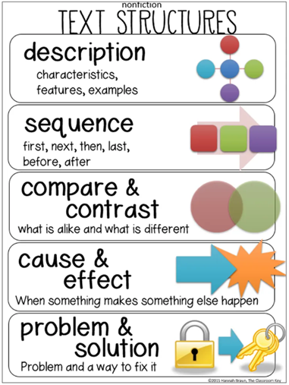
As you think through the best structure, record your ideas for subtopics. What are at least 3 subtopics that support your big idea? Once you have decided on your subtopics, start taking notes in your reading using boxes and bullets, or by using a different page in your notebook for each idea.

