Bryn Mawr Elementary School

4TH GRADE ACTIVITIES
Week of April 13th-17th
SUBJECT | LEARNING ACTIVITIES
READING | - Read for 30-45 minutes every day. You can do that reading with any books, but…  - Read at least one nonfiction text this week. You can read one of these…  - “Comic Craze!” - Do you like Smile or The Babysitters club? Then you might like this Time For Kids article.  - Any Times For Kids article… they’re all free!  - Any nonfiction text in your 4th grade district packet.  - Any nonfiction book you are interested in.
WRITING | Summary Practice  - Choose what you want to summarize. Will it be the whole article you read? Or a smaller section, like “Then and Now” in “Comics Craze!”?  - Write about the main idea. Here are some strategies to help you…  - What are words that are said over and over? What did you learn about them?  - Does this fit the whole part you are summarizing? Or just a little piece?  - Look at the start, the end, and the text features. What do they all have in common?  - What is the text structure? Could it help you?  - Check with: Guess what! “Main idea”. For example, “Guess what! Dogs.” Shows you do not have a main idea. “Guess what! Dogs have many jobs,” makes sense, so it could be the main idea.  - Write about at least three facts that connect to the main idea.
MATH | - Do word problems every day-- at least one! We still suggest Bedtime Math. If you can’t access it, there are word problems in your math packet, or make up your own!  - Use Dreambox every day if you have access.  - Play a math game every day. Play at least one fraction game.  - Can’t print ours? Make your own fraction game:  - Cut some pieces of paper to use as cards.  - Put a fraction on each card.  - Put the cards in a bag and shake them up  - Each player pulls a card from the bag. The player with the highest fraction wins, and takes all the cards.  - The winner has the most cards at the end.  - Here are the resources we attached to help you:  - Big Ideas About Fractions -- parents should read this if they are helping you!  - Two printable fractions games (just color in the one that says put counters on)  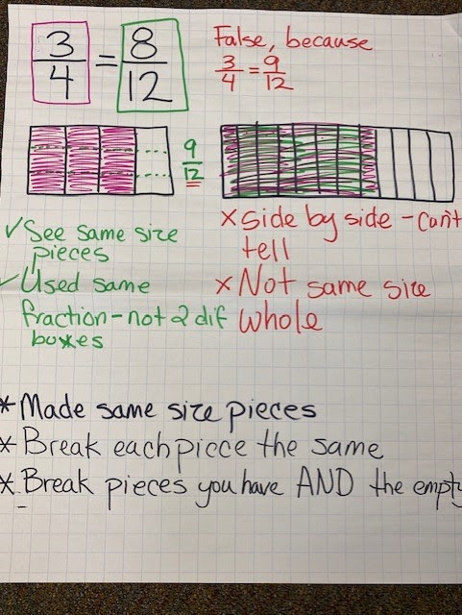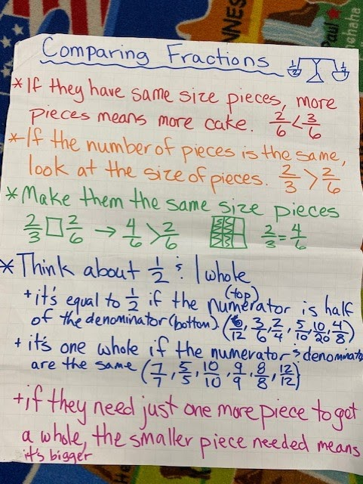
ART | Make a growth mindset poster to motivate yourself to work every day! Draw and color a self-portrait (picture of yourself) in the middle of the paper. Around yourself, write words or phrases to help you persevere. Keep your poster where you will see it often- like hanging it up where you sleep or eat. Some phrases you might write are…  - I can do this!  - Keep up the good work!  - I will keep growing my brain!  - Mistakes help me learn!  An example of a poster:  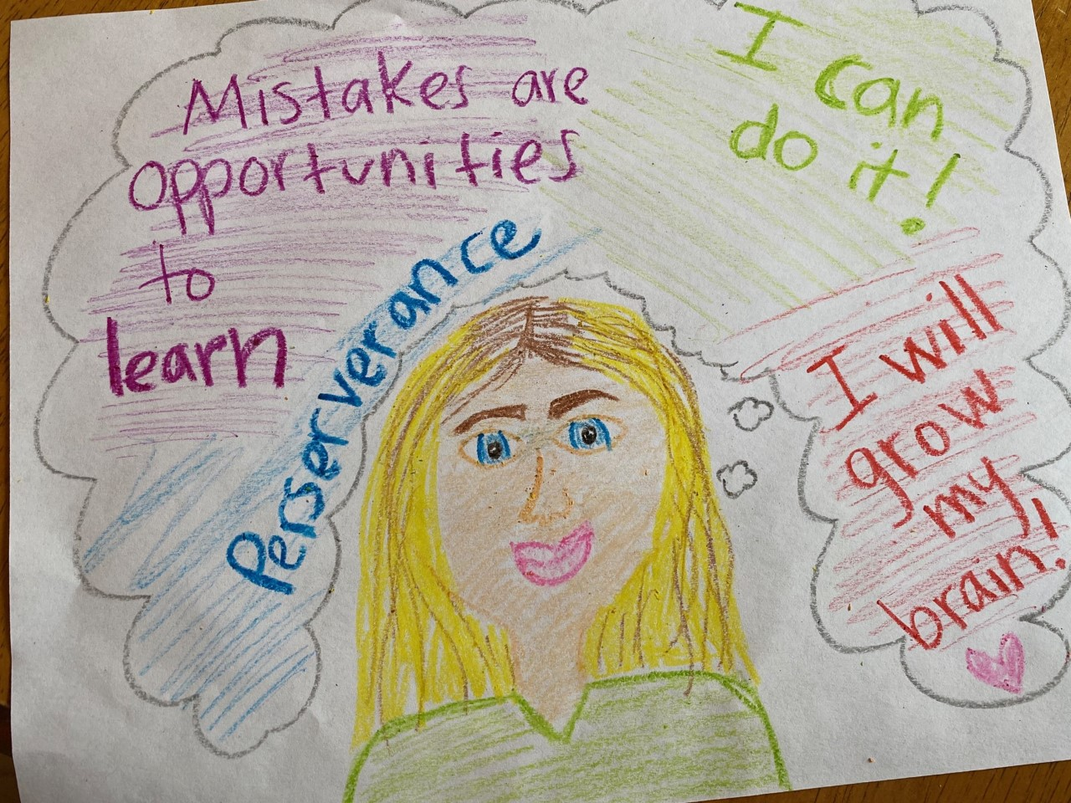
MUSIC | Hello Musical Mustangs!  Let’s go on a m u s i c a l j o u r n e y! You’re going to need a way to listen to music and your parents to help you with this. This week Mr. Deuel and I would like you to explore different styles of music. The goal is to talk about different musical styles, and give at least two reasons why you like a certain style or not. Here’s how you can do this:  - Using music in your house or music you find online, explore the different styles on the image below.  - Using the image below, try to see if the song you listened to is rock, rap, classical, and so on….  - Write down in your journal two reasons why you think it is the style you decided, and two reasons why you like it or do not like it.  - Extra stuff for fun: Film yourself talking about this music and send it to me in Class Dojo OR email it to jdupea@g.rentonschools.us  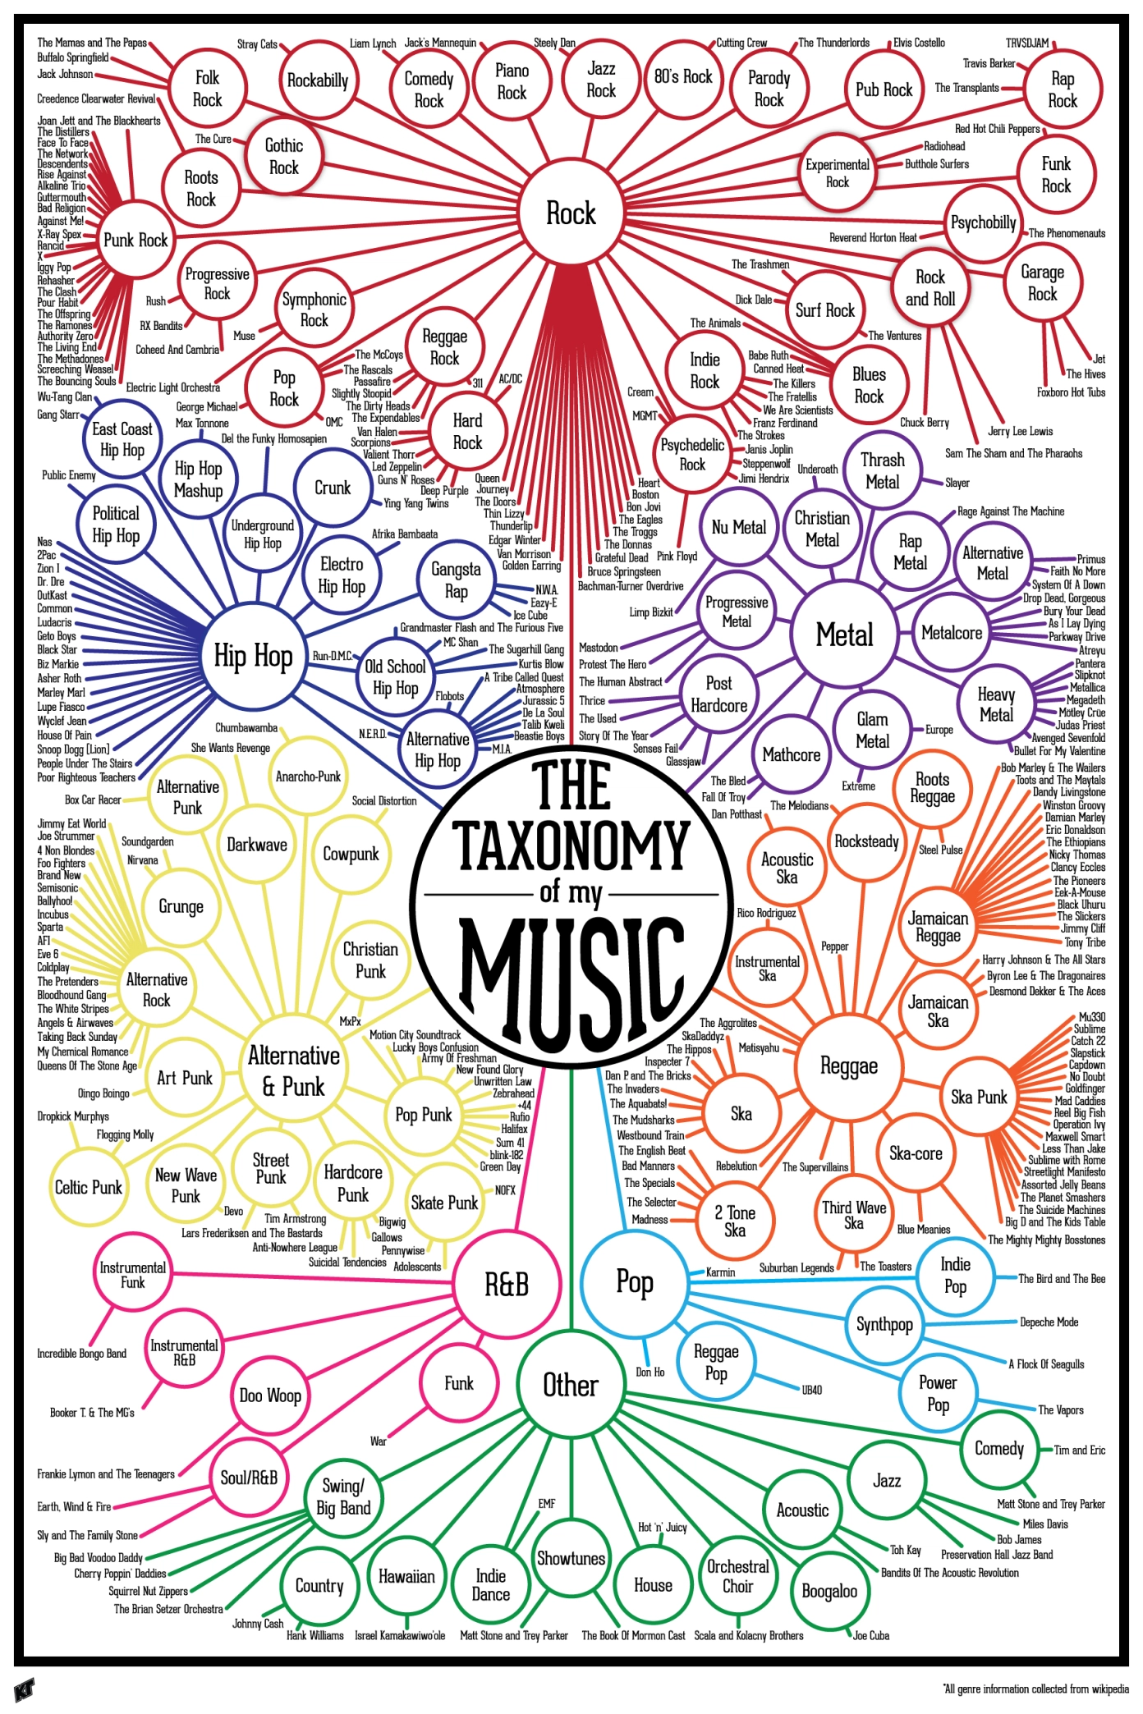  *If you’re interested in more music activities and music videos, email Mr. Dupea at jdupea@g.rentonschools.us to see how to log in to Classdojo.com or Classroom.google.com
PE | 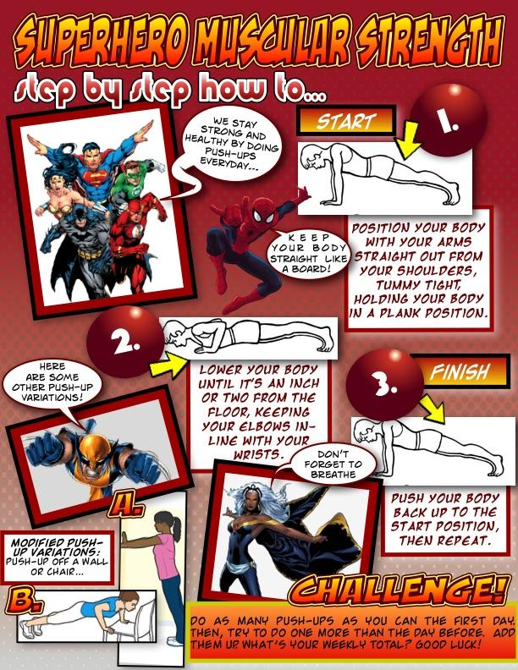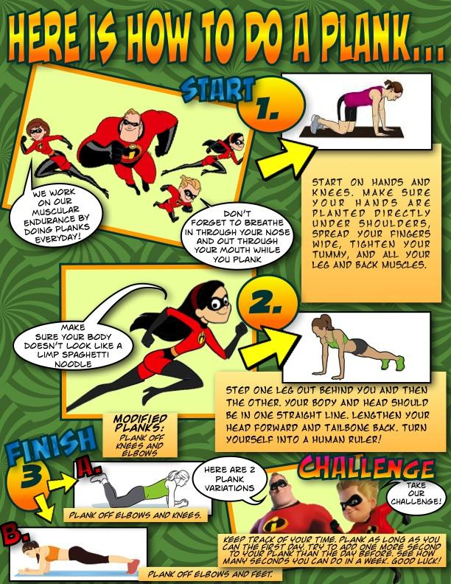  - - - - - - - - - - - - - - - - - - - - - - - - - - - - - - - - - - - - - - - - - - - - - - - - - - - - - - - - - - - - - - - - - - - - - -  Air Bowling: A Stationary Target Activity  A game of practice and fun for K-2nd grade!!  Object of game: Send an object of choice through the air to knock down a variety of targets found from around your home.  Where to play: Outside (or inside *see safety) Learning Target: Throwing at targets to knock them down.  - EQUIPMENT NEEDED:  4-10 empty items: plastic bottles, cans, small cardboard items/boxes of all sizes, (bowling pins if you have them). 1-4 objects for throwing (various sizes, big and small balls): rolled up socks, shoes, bean bag items, big plastic lids, foam noodles, balls.  2. *SAFETY: If inside use soft items (for example socks) to throw and then set your boundary a safe distance from walls with windows or breakables. Be careful!  3. RULES:  -You get 2 throws to try and knock down items (just like in real bowling).  -Take turns with partner😊  -Have fun!  4. PARTNER CHALLENGE OR SELF-CHALLENGE:  Partner Challenge: Trade off setting up and knocking down the targets. One sets up, the other gets two tries to knock the targets down, then trade places.  Self-challenge: How many tries did it take you to knock the target down? Reset and try to beat your score. Partner Challenges: Set a distance and an order for hitting the targets that creates the best challenges.  5. THROWING FORM SUGGESTIONS:  --Step with opposite foot  --Underhand throw = swing arm gently like a bell  --Overhand throw= start with elbow up and out, and hand by ear  6. SCORING: add your points for each throw  STRIKE= ALL items knocked down in one throw! How many times did you get a strike?  SPARE= All items knocked down in 2 tries of throwing. How many items did you knock down in first throw?  FUN THINGS TO THINK ABOUT:  Did you throw overhand or underhand? Which throwing item worked best for you (a big object or a small object to send)? Did you need to get closer to the target or further away? Modify for what works best for you and partner!  - - - - - - - - - - - - - - - - - - - - - - - - - - - - - - - - - - - - - - - - - - - - - - - - - - - - - - - - - - - -- - - - - - - - - - - - - - -  Air Bowling: A Stationary Target Activity  A game of practice and fun for student’s 3rd-5th grade…sending an object of choice through the air to knock down a variety of targets found from around your home… Learning Target: Throwing skills and effort awareness- applying force to send an object at targets to knock them down.  1. You need 4-10 empty items for stacking or self-standing (plastic bottles, cans, small cardboard items/ boxes of all sizes, bowling pins if you have them). 1-4 objects for throwing (various sizes, big and small balls). Optional items for throwing if you do not have a ball: rolled up socks, shoes, bean bag items, big plastic lids, foam noodles.  2. For Safety: Inspect the activity area and make sure it is safe for throwing. Set your boundary a safe distance from walls with windows or breakables. If inside use soft items to throw.  3. This activity can be done as a partner challenge or self-challenge. First have a practice session. You can set up two targets and practice your throws. Partner Challenge: Trade off setting up and knocking down the targets. When ready challenge each other. One sets up, while the other one gets two tries to knock the targets down, then trade places. Self-challenge: How many tries did it take you to knock the target down? Reset and try to beat your score with less tosses. Both Challenges: Come up with a distance and an order for hitting the targets that creates the best challenge and the most fun.  4. Things to think about for throwing: How many items can you knock down in one throw? Did you get a strike (knock all down at once)? How many times did you get a spare (second try got them all down)? Did you throw overhand or underhand? Which throwing item worked best for you (a big object or a small object to send)? Did you need to get closer to the target or further away? Were you able to come up with other items for sending or knocking over the targets that I did not think of? We would love to hear your feedback.  CHALLENGE OPTIONS: Throwing the shoe like a football, plastic lid like a frisbee, foam noodle like a javelin,  bigger items, smaller items (remember no breakables). Make the throwing distance further or shorter. Whatever works best for you and your partner. Using a bat or racquet to strike items towards the target (see items below).  ADAPTIONS: To decrease the challenge, you can decrease the distance, lower the targets, roll a ball on the ground. Use only large targets (e.g., empty jugs, cartons, liter bottles, cereal or cracker boxes). If challenging a younger person let them move closer to the target. To increase the challenge, increase the distance. Use different throws; overhand, underhand, lob. Use a striking implement to send the object towards the target (bat, hockey stick, racquet).  MOVEMENT STRATEGIES: Applying appropriate skills to send an object to improve control and accuracy. Throwing keys to success: Underhand throw-Stand facing your target, swing your throwing arm back with ball in hand, step with opposite foot forward as you throw, release release ball between your knee & waist level, following through with hand towards object. Overhand Throw – Stand sideways to your target T-up, bring your throwing arm back (make upper case “L” with throwing arm at shoulder height), step with opposite foot of throwing arm forward (as you throw your elbow leads the throw), rotate your hips and spine as you throw following through with your hand to the target!  ------------------------------------------------------------------------------------------------------------------------------------------

