Activity | Car/bike wash
Materials | Car or bike, Squirt bottle/rag, dish soap, buckets of clean and soapy water
Skills Targeted | Fine motor and gross motor coordination and strength
Instructions: | - Set up an outdoor car wash! Bring your bike or car to a concrete or grassy area (avoid areas that could be slippery)  - Squirt or wipe with soapy water.  - Wipe down or squirt with clean water  - Make sure to get all areas clean! (a good squat is very helpful in developing lower extremity strength)  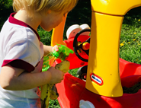
Modifications: | - If your child is not yet sitting or standing, this activity can easily be modified into a seated activity washing matchbox cars (or dishes!) Place one clean bin to the left of your child and a soapy bin to the right. They can work on various sitting positions and cross body reach.

