5TH GRADE ACTIVITIES
Week of March 30th-April 3rd
SUBJECT | LEARNING ACTIVITIES
READING | Continue research on Westward Expansion by the end of the week you should have chosen your topic and 3-5 subtopics (more information on ways to choose and organize subtopics below)
WRITING | Work on the rough draft of your fiction story using your story mountain and the work you have done on character development and the fifth grade writing checklist.  Share your finished rough draft with someone at your home and ask for what they liked and where they were confused  *Ms. Thomas’ class will need to put together their snippets into one final draft. Assignment is on Google Classroom.
MATH | Work on memorizing your basic multiplication and division facts through 10 x 10  Work in your Spiral notebook on one of the decimal pages added below. Answers are included at the bottom to check your work.  Choose a few “Which One Doesn’t Belong” activities from this site http://wodb.ca/. Talk with a family member about which one you each think doesn’t belong, and why you think so. Be careful! There may be more than one right answer.
SCIENCE | Watch this Magic School Bus video then share with your family or write in your spiral an example of a food chain in this ecosystem.  https://www.teachertube.com/videos/msb-gets-swamped-378988  Watch, listen and explore Kenai Fjords National Park. Share with your family or write in your spiral adaptations plants and animals would need to develop in order to survive in this ecosystem.  https://artsandculture.withgoogle.com/en-us/national-parks-service/kenai-fjords/exit-glacier-tour
MUSIC | Create Music  Use the program Song Maker to spell your name. If your name is long, try doing part of your name, a nickname or stacking it. Play around with different colors that sound good together and include spaces (rests). Also try changing the instrument and percussion sounds to make it just right.  Webpage Link: https://musiclab.chromeexperiments.com/Song-Maker/  Youtube Tutorial: https://www.youtube.com/watch?v=AFEVjA7NM-o&t=10s  Mr. Dupea’s Example: https://musiclab.chromeexperiments.com/Song-Maker/song/4904801915633664
PE | 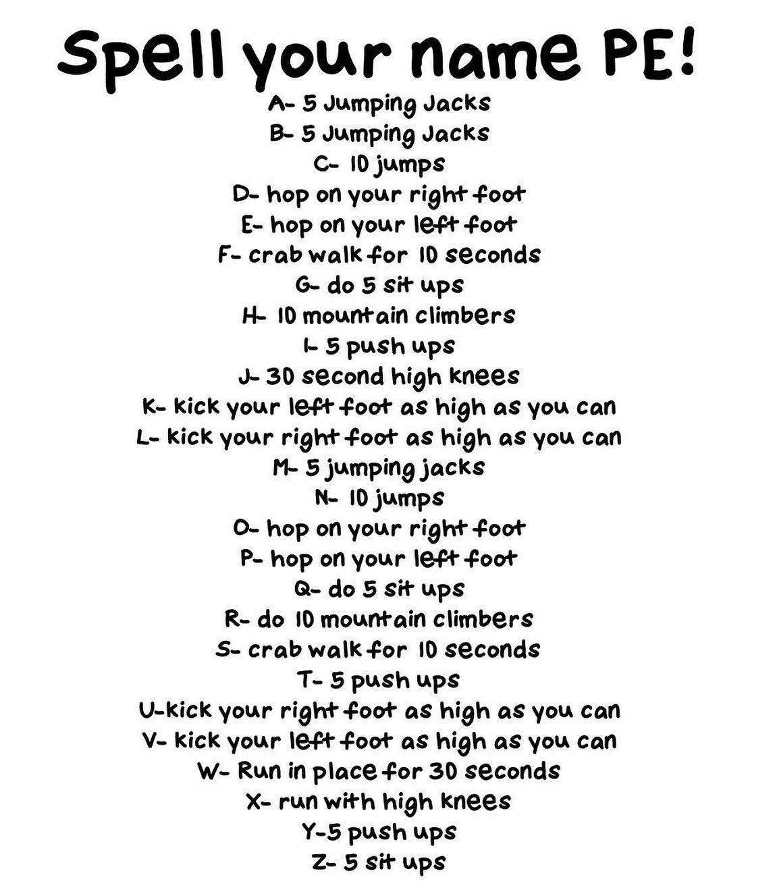
Westward Expansion Research Report: Organization

You have spent the last few weeks introducing yourself to Westward Expansion, and getting an overview of what it is. Now it’s time to start narrowing your research and organizing your notes. This week, you will choose a big idea for your research. Then you will think through at least 3 subtopics that connect to your main idea. The checklist your teacher provided lists your topic choices for your report. Topic choices include:
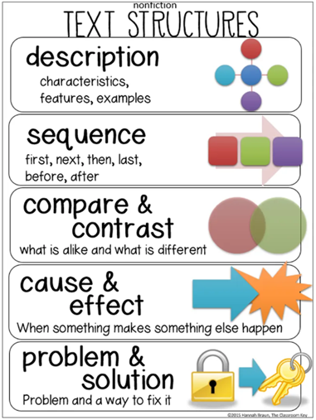
· Louisiana Purchase
· Gold Rush
· Lewis and Clark
· Sacagawea
· Buffalo Soldiers
· Oregon Trail
· Pony Express
· Pioneer Living
· Biography of a Famous Person at this time (e.g. Annie Oakley, Buffalo Bill, Daniel Boone, Tecumseh…)
Organizing Subtopics

Once you have chosen your topic, it’s time to think about your subtopics. How do you plan to organize your writing? Look at the diagram on the right for some typical text structures.

Ask yourself: what structure would make sense with your topic? Should you take your readers through the story in chronological order, telling what happened first, second, and last? Maybe you want to include different points that are important to the topic. Perhaps you want to share a problem that happened before Westward Expansion, and then how it was solved?

As you think through the best structure, record your ideas for subtopics. What are at least 3 subtopics that support your big idea? Once you have decided on your subtopics, start taking notes in your reading using boxes and bullets, or by using a different page in your notebook for each idea.
