Activity | Design your own nature sculpture from your backyard
Materials | Natural materials from your yard, leaves, twigs, pinecones, stones
Skills Targeted | Visual perception (finding target objects), sorting skills, tactile (touching), imagination
Instructions: | - Collect materials from nature (leaves, twigs, pinecones, stones...)  - Any design counts as a unique natural art piece  - Picture examples:  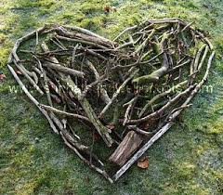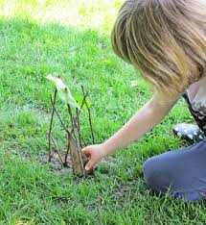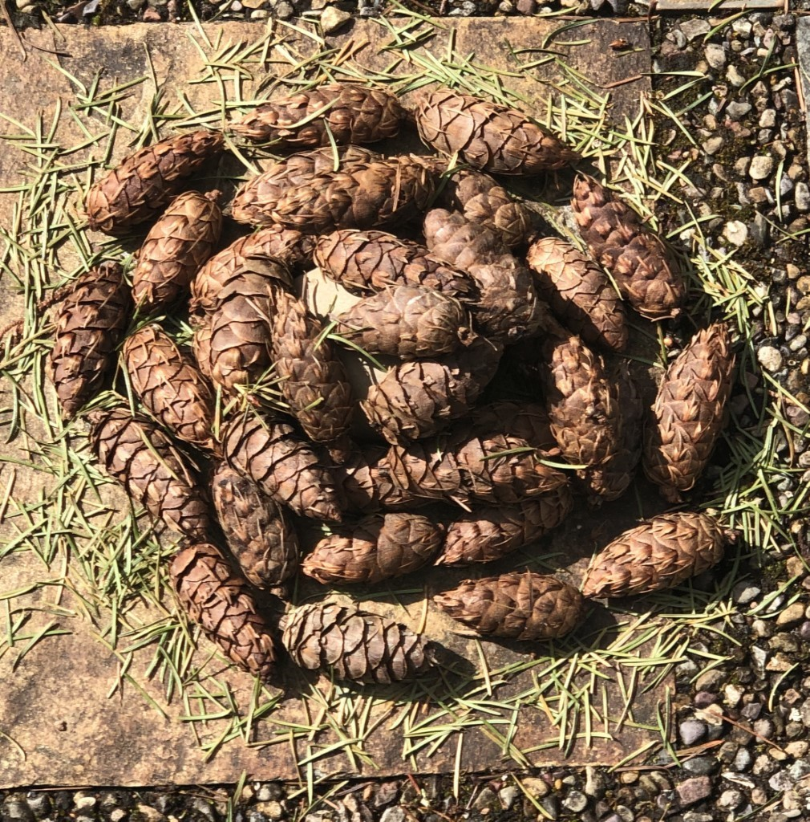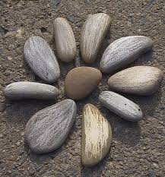
Modifications | - Parents can pick up materials for child  - Parents can make a sample to let child copy  - For younger children, parents need to watch for oral safety (without putting items into their mouths)

