1st Grade Math
March 30th-April 3rd

Students will need paper to complete these mathematical tasks.

Day 1

Number Sense
You have the following digits… 7, 5, 2, 4, 6, 3. What is the largest 2-digit number you can make? What is the smallest 2-digit number?

Equality (Source: https://www.openmiddle.com/)
Using the digits 1 to 9, at most one time each, fill in the boxes to create a true number sentence with the greatest possible value.
Counting
How many oranges are there? How did you count them? (Source: visualpatterns.org)

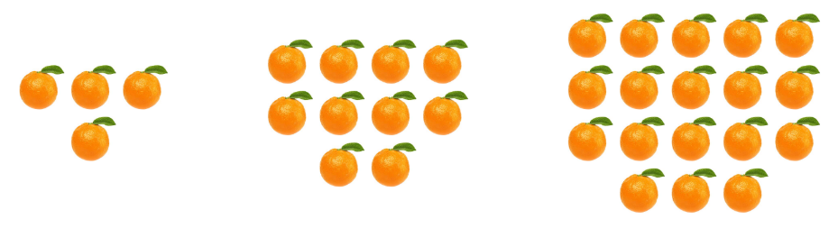
Day 2
Word Problem
There were 3 apples on the table. Jan put 6 more apples on the table. How many apples were on the table in all? Show your work.
GGuess My Number Game
Materials: None (Pencil and paper optional)
This is a great game you can play anywhere. One person thinks of a number between 1 and 10 (or 20, or higher), and the other players try to guess the number. After each guess, the person with the number says whether their number is greater or less than the guess. Guessers try to get the number in the fewest number of
guesses possible. (Source: mathforlove.org)

Interpreting Data
Make a graph that shows a possible result of 7 students’ favorite color with red being the most popular color. (Source: https://www.openmiddle.com/)

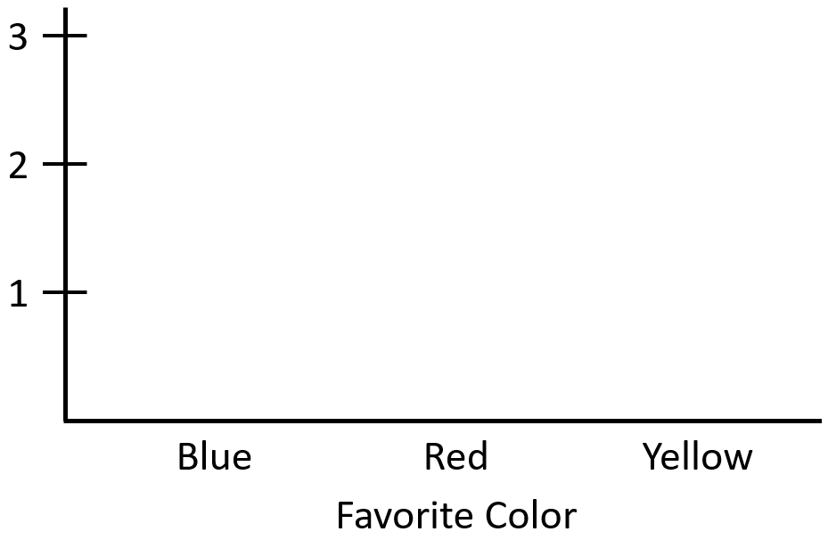

Day 3
Drawing
Make a picture that is worth 14¢. You can use as many as you like of these shapes. Label your picture. Prove that it is worth 14¢. (Source: mathlearningcenter.org)

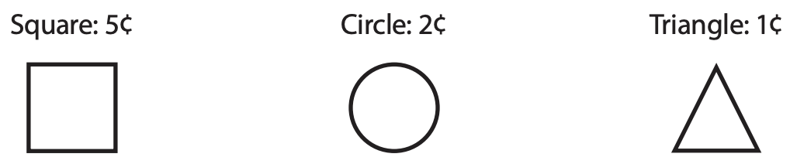

Which One Doesn’t Belong?
Choose one shape in this picture that you don’t think it belongs with the rest. Explain why. Can you pick another shape and give a different reason? (Source: wodb.ca)

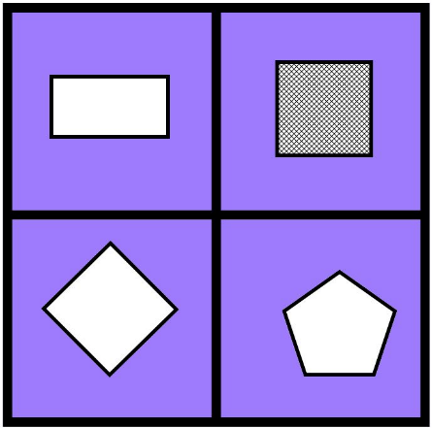

NNoticing
On a piece of paper, make two columns. In one column, list the things that are the same in this picture, and in the other column, list the things that are different. (Source: https://samedifferentimages.wordpress.com/)

