Activity | Q-tip Painting
Materials | Q-tips  Washable paint  Printer paper, watercolor paper or cardstock  Picture Template (optional!) Create your own or cute and paste one of these links for a print-out:  https://drive.google.com/file/d/0B7HU0DcVrlesVzNPSmdWczQtVzQ/view?usp=sharing  http://www.makinglearningfun.com/themepages/DoaDotMiniMarkerPage.htm
Skills Targeted | Fine Motor grasp, hand/finger strength, fine motor force, sensory tolerance
Instructions: | - Gather materials. Set up paper/picture with dots and different paint colors with one q-tip for each color of paint.  - Talk about/demonstrate use of q-tip to make dots to color and/or create a picture. Demonstrate how pressing down lightly will make a small dot, more pressure will create a larger one.  - Encourage student to hold q-tip with pads of thumb and index finger while filling in dots to create a picture.  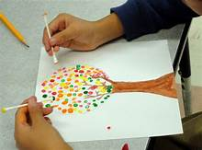  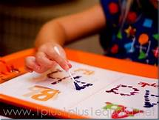
Modifications: | - Have child “paint” letters using same sequencing they would for drawing letters (starting at the top)  - Cut q-tips in half to accommodate small fingers  - For more challenge:  - Encourage child to use a different color one each side of q-tip and to flip the q-tip from one color to other without using other hand (in-hand manipulation) while painting  - Have child complete activity while lying prone on tummy or while paper is taped to wall for shoulder strengthening

