Activity | Number Jumps
Materials | Your body, Chalk, sidewalk/driveway
Skills Targeted | Lower body strength, coordination and number identification
Instructions: | Pick a space to set up a number grid in chalk. Start at the middle star. Call out numbers for your child to jump to.  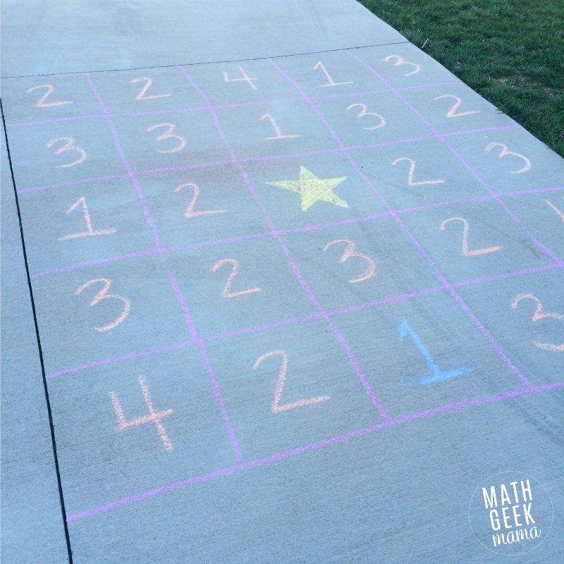
Modifications: | - If your child is just learning to stand, focus on supported standing and possibly attempting toe taps to a nearby number and/or walking with support to a nearby number.  - If your child is just learning to sit, focus on upper extremity and trunk movements while giving support at your child’s trunk. Give support while your child reaches to tap a number with their hand. (attempt only nearby numbers)  - If your child is not yet sitting or standing/walking is not a skill they have yet, rolling/crawling is another option.  - High level skills: If your child is able, you may modify to single leg hops to increase the challenge. You can also modify this to involve calculations, ex: 2+2 (jump to #4.)

